Chapter 4 Ground Improvement with Admixture or Inclusion

Abstract: In this chapter, the techniques of Ground Improvement with admixture or inclusion. Specifically, Surface compact using cement and lime, Sand compaction pile and Stone column are described. They are consisted of procedures by adding some chemical solidifying materials in soils and by including other materials into the ground.

Keywords: Soil-cement, Soil-lime, Sand compaction pile, Stone column,

4.1 Introduction
Ground Improvement with admixture or inclusion is the improvement method in which either admixtures such as cement and lime or inclusions such as sand or crushed stones are used in the ground. Basically three different techniques are available: 1) Surface compact using chemical solidifying materials such as cement and lime, 2) Sand compaction pile using inclusion made of sand and 3) Stone column using inclusions made of crushed stone.
Soil-cement is a mixture of pulverized soil and Portland cement with some water, compacted to high density. As the cement hydrates, the mixture becomes a hard and durable soil mass. The soil materials can be almost sand, silt, clay and gravel.
Lime is the oldest traditional stabilizer used for soil stabilization. The mechanism of Soil-lime treatment involves cation exchange, which leads to the flocculation and agglomeration of soil particles. Soil-lime effectively increases the strength, durability and workability of the soil. Such treatment also improves soil compressibility.

Sand Compaction Pile method is used frequently in construction to form compacted sand piles by vibration, dynamic impact or static excitation in soft ground. This method improves stability or compressibility and prevents liquefaction failure in loose sand, the SCP method is now often applied to soft clay ground to ensure stability and reduce ground settlement.

Stone column is an array of crushed stone pillars placed with a vibrating tool into the ground below a proposed structure. Such techniques increase the load and drainage of the soil while reducing settlement and liquefaction potential.
4.2 Surface compaction using cement and lime

Surface compaction using cement and lime is the method to increase the strength of soil by adding admixtures in soil, mixing and compacting them. The typical admixtures are Portland cement and lime, and sometimes the admixtures are named the solidifying materials.
When earth structures like roads are built with embankment materials from borrow pits, in general, the compaction method (described in Chapter 2) is applied. However, if the embankment materials have insufficient engineering properties (e.g. strengths, bearing capacities and durability etc.,) the ground improvement with admixture is adopted as a solution for these problems. The procedures of this method consist of 1) pulverizing of embankment materials, 2) mixing them with admixtures, 3) grading and 4) compacting.
When earth structure is constructed by using surplus soils generated at the sites, this method can also be applied, because the surplus soils aren’t often suitable for building of earth structure.
In addition, if there is a soft soil layer at shallow depth, with insufficient strength or its bearing capacity to construct structures on it, the soil strength may be increased by this method in which the soil layer is first excavated, and then mixed with admixture and finally compacted in usual manner.

4.2.1 Admixtures
Mainly used admixtures are Portland cement, cementitious solidifying material, quick lime, hydrated lime and lime-based solidifying material. Each admixture is described below:
(a) Portland cement
When Portland cement is added with water, the mixture hydrates. When soil and Portland cement with some water are mixed, the mixture becomes a hard and durable structural material. Table 4.1 shows typical constituents of Portland cement clinker and its products after the hydration.

Table 4.1. Portland cement and products after hydration (Wikipedia, 2016)
Clinker | Abbreviation | Mass % | After hydration
Tri-calcium silicate | C₃S | 45-75 | C₃S₂･2H₂O + 3Ca(OH)₂
Di-calcium silicate | C₂S | 7-32 | C₃S₂･3H₂O + Ca(OH)₂
Tri-calcium aluminate | C₃A | 0-13 | C₃A･6H₂O
Tetra-calcium alumino-ferrite | C₄AF | 0-18 | C₃A･6H₂O + C₃F･6H₂O
Gypsum CaSO₄･2H₂O |  | 2-10 | C₃A･3CaSO₄･32H₂O
(NOTE) C: CaO, S:SiO₂, A: Al₂O₃, F:Fe₂O₃

The different constituents slowly crystallize and the interlocking of their crystals gives the cement its strength. Carbon dioxide is slowly absorbed to convert the portlandite into insoluble calcium carbonate. After the initial setting, immersion in warm water will speed up setting. The products after hydration are generally called C-S-H gel and products of pozzolanic reaction. If Portland cement is mixed with soil and some water, S-S-H gel and products of pozzolanic reaction fill the pore between soil particles and harden the mass by composing of soil particles. However, the gain of its strength will terminate after a few weeks.
(b) Cementitious solidifying material (Japan Cement Association, 2012)
Soil-cement method with Portland cement has some demerits as Portland cement has no effect when used in clayey soils and organic soils. In order to make it suitable for clayey soils and organic soils, cementitious solidifying material has been developed by adjusting of the chemical composition on the cement based material. It is a powdered material which is obtained by increasing the SO₃ component of original Portland cement, through addition of fine powders from furnace slag or fly ash and so on.
For example, gypsum becomes ettringite (C₃A･3CaSO₄･32H₂O) by the hydration reaction, as shown in Table 1. Because ettringaite is a needle crystal with large amount of water, the cementitious solidifying material with gypsum is effective in treating the high moisture clayey soil.
(c) Quick lime and hydrated lime
Quick lime is the calcium oxide and its chemical formula is CaO. Hydrated lime is the calcium hydroxide Ca(OH)₂ and it is obtained when quick lime is mixed, or slaked with water. Quick lime with water produces hydrated lime and releases thermal energy according to the following equation.
CaO + H₂O Ca(OH)₂ (ΔH_{r} = -63.7 kJ/mol of CaO)
Quick lime and hydrated lime can increase the soil strength and bearing capacity of clayey soils. They can function as solidifying materials through chemical reaction of fine silicates and aluminates, which possess cementing properties. Therefore, soil-lime is evaluated to be more effective for clayey soil than sandy soil. Moreover, lime produces some decrease in plasticity index, and also the heat energy produced during the hydration of quick lime aids in draining and drying of high moisture clayey soil. Addition of lime to expansive soils may decrease their swelling potentials too.
(d) Lime-based solidifying material
Lime-based solidifying material is a material which contains lime as the main components and also contains gypsum, slag and pozzolanic materials (alumina, fly ash etc.). It is effective in the treatment of high moisture clayey soil or organic soil.

Table 4.2 shows the relationship between above-mentioned four solidifying materials and suitability of soils to be improved.

Table 4.2. Relationship between solidifying materials and soils
(Modified and reconstituted from original Table, Japan Cement Association 2012)
Solidifying material |  | Cement | CSM | Lime | LSM
Soil types | Sandy soil | 〇 | 〇 | △ | △
Soil types | Clayey soil | 〇 | ◎ | ◎ | ◎
Soil types | Volcanic clayey soil | 〇 | ◎ | ◎ | ◎
Soil types | Organic soil | △ | ◎ | 〇 | ○
Soil types | Highly organic soil | × | ◎ | △ | △
Soil types | Soft clay (w_{n}<w_{L}) | 〇 | 〇 | 〇 | ○
Soil types | Soft clay (w_{n}>w_{L}) | △ | 〇 | △ | △
Remarks | Handling for wet soil | △ | △ | ◎ | ○
Remarks | Initial strength | △ | ○ | △ | ○
Remarks | Long term strength | ○ | ○ | ○ | ○
Note ◎: Best, 〇: suitable, △: suitable to some extent, ×: unsuitable
CSM: Cementitious solidifying material,
LSM: Lime-based solidifying material

4.2.2 Engineering properties of solidified mass
Finer by weight
Fig.4.1 (Japan Cement Association, 2012) shows the relationship between the amounts of solidifying material added and unconfined strength of solidifying mass by cementitious solidifying material. The unconfined compressive strengths of solidified specimens increase linearly with admixture amount, however the difference in strength is observed depending on the soil types.
Fig. 4.2 (Japan Lime Association, 2016) shows the compression strengths of quick lime, hydrated lime and lime-based solidifying material according to the adding amounts of solidifying materials.
These figures show that the strengths of the solidified masses with admixtures are different depending on the soil types, kinds of mixing materials and adding amounts. Therefore, the blending test of solidifying mass (in the laboratory) should be performed to decide the adding amounts of admixtures. Fig. 4.3 (Japan Lime Association 2016) shows an example of the test results, in which the horizontal axis shows the amounts of admixture and the vertical axis shows the strength values such as the unconfined compression strength, cone index and CBR etc. When using this figure, it is important to notice that there is a difference in strength by the laboratory test and the strength in the field. The ratio between the field strength and the laboratory strength of solidified mass is different depending on the mixing method of admixtures. One typical example is shown in Table 4.3.
Table 4.3. Strength ratio (Site strength / Laboratory strength) (Japan Lime Association 2016)
Soil type | Mixing method | Strength ratio
Ordinary clayey soil | Mixing by stabilizer | 0.5-0.8
Ordinary clayey soil | Mixing by backhoe | 0.3-0.7

The procedures for deciding of the adding amount are as follows;
1) Prepare a figure similar to Fig.4.3 by blending test (laboratory strength).
2) Decide the design strength.
3) Decide the target strength, which is the design strength divided by the strength ratio.
4) Determine the adding amount of admixture as the value which corresponds to the target strength on the graph.

When clayey soils with high moistures are treated by admixture, it is recognized that the moisture content and the plasticity index is decreased, especially in quick lime. Fig.4.4 (Japan Lime Association 2016) shows the relation of quick lime mixing rates and soil’s moisture contents. Fig.4.5 (Japan Lime Association 2016) shows the relationship between the quick lime mixing rate and moisture contents of soil. It is seen that the values of liquid limit decrease as the quick lime mixing ratio is increased, however, at the same time the values of plastic limit also increase. As the result, the plasticity indices of the tested soils decrease.

4.2.3 Procedures of improving methods
Fig.4.6 shows the procedures of surface compaction with admixtures (using cement, cementitious solidifying material, lime and lime-based solidifying material). These procedures are represented in three systems depending on the mixing modes: “On site mixing system”, “Plant mixing system” and “Borrow pit mixing system”. “Borrow pit mixing system” may be applied in materials of slow chemical reaction, such as hydrated lime etc.

4.2.4 Application
Recommended applications of this type of ground improvement methods are as follows:
- Maintain the traffic-ability of construction machines.
- Improve the strength and the bearing capacity of shallow foundation and road embankment (subgrade, base course etc.)
- Improve the compressibility of backfilling soil etc..
- Improve the surplus soil for reusing of construction generated soil.
4.3 Sand Compaction Pile Method

4.3.1 Description
Sand compaction pile is a method, in which dense and compacted sand piles with expanded diameter are driven and placed in the ground by using vibration or hammering. This method is applied for the purpose of improving loose sandy ground or soft clayey ground by inserting sand piles.
When sand compaction piles are applied for loose sandy ground, the ground will be compacted by the pressurizing effect of sand piles. The shearing resistance of the ground will be increased due to decrease of the voids within soil mass. Liquefaction of ground during earthquake can be prevented using sand compaction piles, through reduction of the liquefaction potential of loose sandy grounds. Fig.4.7 (Takahashi, 2008) shows a typical example of liquefaction prevention of foundation soils in case of quay wall. On the other hand, when sand compaction piles are placed in soft clayey ground, the ground will be improved by the forced replacement of soft soils and the consolidation effects due to drainage function of sandy inclusion. The bearing capacity and the shearing strength of soils will be increased as the composite ground from the view point of theoretical geo-mechanics. Fig.4.8 (Takahashi, 2008) shows an adopted example of this method with the purpose to improve soft clayey ground when constructing road embankment.

4.3.2 Principle
Sand compaction pile (hereinafter SCP) is used to improve ground stability by installing large diameter compacted sand piles in the ground. These sand piles mobilize large shear strength due to formation of composite ground. This mechanism improves the ground through increase of bearing capacity and factor of safety of slope. Due to their stress redistribution effect, sand piles are able to increase the bearing capacity of composite ground consisting of sand and clay and thus, can reduce the amount of ground settlement.
Fig.4.9 (Fudo, 1971) shows the principle of ground improvement for sandy soil using Sand compaction pile. As shown in Fig. 4.9a, if the void ratio of original ground is e₀, the volume of it can be expressed as (1+e₀). If the amount of sand corresponding to Δe is pressed into this ground, the void ratio will be reduced by that amount. The decrease in void ratio is evaluated as the improvement effect. The ratio of the amount of pressed-in sand to the volume of the original ground is called the replacement rate (a_{s}), which is in principle is nothing but the degree of ground improvement, and is expressed by the following equation.
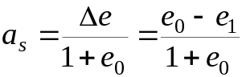
(4.1)
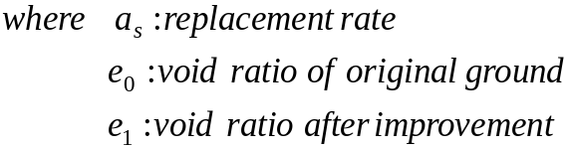
The replacement rate can also be expressed by the cross sectional area ratio of sand piles to be driven against the objective ground area. Fig.4.10 (Fudo, 1971) shows Plane arrangement of SCP, which are illustrated in (a) square pattern, (b) equilateral triangular pattern and (c) parallelogram pattern. In each case, replacement rate (a_{s}) is expressed by the following equation.
(a) and (c) Square and Parallelogram (rectangular)
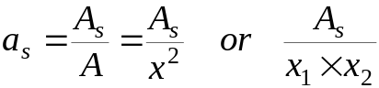
(4.2)
(b) Equilateral triangular
(4.3)
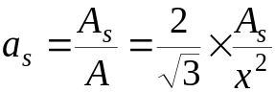
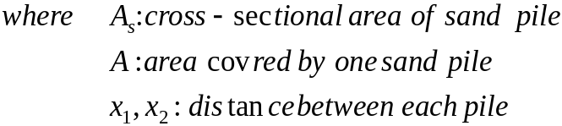

4.3.3 Procedure

Sand compaction piles consist of driving a hollow steel pipe down to the required depth. The bottom of steel pipe is closed by means of a freely movable plate. The hollow pipe is filled with sand, and thereafter, the pipe is withdrawing the pipe while air pressure is directed the sand inside it.
Fig.4.11 (Yasuda et al 1996) shows the general procedures for SCP method, which consist of re-driving and compaction process. After penetrating a casing into the ground, sand is filled into the casing. Then by withdrawing the casing, the sand is discharged into the bored hole and then compacted by vibration. The surrounding subsoils are also compacted during this process. Usually, when a 50 cm diameter casing is used, the compacted sand pile diameter will be 70 cm. The spacing between each sand compaction pile varies from 1.2 m to 3.0 m.

4.3.4 Design procedures

- In the case of sandy ground
Various design methods have been proposed for applying SCP to sandy ground. The following three means are proposed for its design, when applying it for sandy soil.
ⅰ) Using charts, which are based on N values from case histories,
ⅱ) Using charts, which are based on relationship amongst N values, D_{r} and e,
ⅲ) Consideration of the fine fractions of original ground.
Herein, the conventional design procedure based on N values, which is considered to be the simplest in many applications, is described.
Fig.4.12 (Fudo,1971) shows N-value after being improved by SCP, which is based on the data from the past case histories. N₀ on the horizontal axis shows the ground strength before the construction of SCP, and N₁ on the vertical axis shows the ground strength after the improvement by SCP, which were measured between the sand piles. This figure is summarized with a_{s} indicated as a parameter. In this figure, parameter a_{s} is referred to the replacement rate of sand piles and is expressed by Equation 4.1 stated in the previous section. An example of the design is shown in Fig. 4.13 (Fudo,1991).
(4.4)
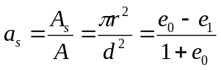
Where, A: sharing area per one sand pile
ｄ：spacing of sand piles
r: radius of sand pile
e₀：void ratio before improvement
e₁：void ratio after improvement

If the simplified figure (Fig. 4.12) is used, the desired replacement rate can be obtained at the intersected point of N₀ of the original ground and the target N₁ after improvement.

- In the case of clayey ground
For the clayey ground, casing pipes are installed in the ground down to the designated depth at uniform intervals. When SCP is applied for the soft clayey ground, the concept of composite ground is required for designing. Harada Kobayashi Fig. 1 here and explain
In case of bearing capacity of composite ground, the following procedure was proposed by Suematsu (1991), which is explained in Fig. 4.14 (Suematu, 1991)
(4.5)
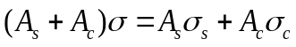
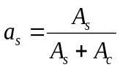
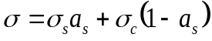
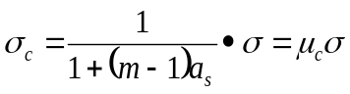 (μ_{c}: coefficient of stress reduction)
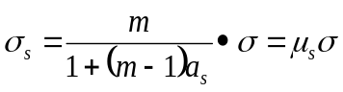 (μ_{s}: coefficient of stress concentration)
Where a_{s}：replacement rate of sand piles,
A_{ｓ}:plane area of sand piles,
A_{c}: plane area of clayey ground
σ_{c}:
σ_{s}:
σ:

A parameter m is the stress sharing ratio and Table 4.4 shows the relation between the replacement ratios a_{s}, the internal friction angle φ of sand and the stress sharing ratios m.

Table 4.4 Relation of a_{s}, φ and m (Fudo, 1971)
a_{s} | φ | ｍ
- ～0.3  0.3～0.7  0.7～ | 30°  30°  30° | 3  2  1

Fig.4.15 (Suematu, 1991) shows the evaluation of the shear strength of composite ground assuming slip failure. The shearing strength τ_{sc} of the composite ground can be expressed by the following equation.
(4.6)

4.3.5 Applications
Table 4.5 shows the relationship between the soil types and aims of ground improvement by SCP.

Table 4.5 Relation between soil type and Aims of improvement by SCP (Fudo, 1971)
Soil type  Aim of improvement | Very soft clay | Soft clay | Loose sand | Alternation of  sand and clay
Increasing of bearing capacity  Reinforcing of shear strength  Increasing of lateral resistance  Prevention for ground settlement  Countermeasure for liquefaction | ◇  ◇  ◇ | ◇  ◇  Δ  ◇ | ◇  ◇  ◇  ◇ | ◇  ◇  ◇  Δ  Δ
(Notes) ◇: dominant Δ:rare
There are many case histories such as embankments, foundations of oil tanks, port and harbor facilities, buildings and so on, in which this method was applied for ground improvement. A typical application from Japan is described below.
SCP was applied as liquefaction countermeasure of the revetment of a sewage plant in Yokohama coastal area in 2009 (Fig.4.16- JAFEC, 2016). Fig. 4.16(a) shows the quay wall and the foundation details of this project. In this project, the average N-value of the original ground was 7, the target N-value after improvements was set to 10 or more. After improvement works, the N-values between the each pile was measured, which are shown in Fig. 4.16 (b). As displayed in the figure, the average N-values increased to more than 15 after the execution of SCP.

4.4 Stone column

4.4.1. Description

Stone column is the ground improvement method for stabilizing non-homogeneous and compressible soils and fills, in which vertical columns of stone (gravel or crushed rock) are placed inside the ground to desired depth. By applying this method, the bearing capacity of the ground can be increased, and the differential settlements or the liquefaction potential can be reduced. This technique is well suited for improvement of soft soils such as silty sand, silt, clay and non-homogeneous fills. Organic soils, peat and very soft clays are not suitable for improving using this method, due to their lack of lateral confinement.

Stone columns are constructed either by wet top feeding method or dry bottom feeding method (Refer to Section 4.4.3). Almost similar equipment, which are used in the vibro-flotation or vibro-compaction method and described in Chapter 2, can be used in stone column construction too. Stone columns are constructed by driving a casing pipe and filling the hole in the ground using stones, and then compacting the stones through vibration during the withdrawal of the casing. The vibrating probe breaks down the pores of surrounding soil, thereby, densifying the soil. Gravel or crushed rock replaces the original soil, and keeps up the pressure on the soil that was created by the vibrating probe.

Stone columns have been used since the 1950’s as a technique for improving both cohesive soils and silty sand. Potential applications include 1) stabilizing the foundation soils to support embankments, approach fills and reconstruction work on weak cohesive soils, 2) supporting retaining structures, bridge bent and abutment structures on slightly marginal soft to stiff clays and loose silty sands, 3) landslide stabilization and 4) reducing liquefaction potential of sands. Also, stone columns under proper conditions can greatly decrease the time required for primary consolidation.

4.4.2. Principle

The basic principle of the ground improvement using Stone column is similar to Vibro-flotation (Chapter 2, Section 2.3) and Sand compaction pile (Section 4.3). However, because the inclusive materials in this method are compacted stone, the evaluation of stone column itself becomes the main constituent in the design. The following can be achieved using stone columns.
- Improving in bearing capacity
- Reduction in settlement
- Increased rate of consolidation settlement of soft soil.
As compared to the sand compaction pile, the rigidity of the stone column is high, and therefore, the improvement principle works on the strength of the stone column alone. The entire soil below the foundation, therefore, acts as a reinforced soil with higher load carrying capacity than the virgin ground. Furthermore, pore-water pressure dissipation by radial flow accelerates the consolidation of subsoil. Fig.4.17 (Som & Das,1974) shows the benefits of stone columns in reducing settlement through load tests, which were carried out on soft clay with and without stone columns.

4.4.3. Procedure

Stone columns are formed by inserting a vibrating probe to incorporate granular aggregate (crushed rock, gravel etc.) into the ground by the following procedures.

- Stone columns are formed by inserting a 130kW hydraulic or electric vibroflot using air as a jetting fluid, equipped with a pressure chamber facility. This combination gives the best results for incorporation of the granular column backfill to the bottom of column and delivers the continuity and optimum compaction required. The vibrating probe penetrates the soil to the design depth or refusal, and as a result the soil is displaced laterally without producing any spoil (Fig.4.18, civildigital,2017)
- As the probe is lifted, the granular fill is deposited into the void by gravity and assisted by the injection of compressed air. The aggregate is then compacted by repeated re-insertion of the vibrating probe, in lift of 30—50cm, until the aggregates reach the surface.
- The final diameter of stone column depends on the properties of the surrounding soils and may vary with depth in non-homogenous soils.

Aggregates are inserted into the hole by two methods: Wet top feed and Dry bottom feed. In the wet top feed method, water jets located in the vibrator’s tip create an annular space around the vibrator though which stone is introduced from the tip. In the dry bottom feed method, a pipe attached to the vibrator supplies stone directly to it.

Wet-top feed system
In wet-top feed method (Fig.4.19, Zetas), the vibrator is lowered down to the desired depth with the help of the water jet, and in the meantime vibrator creates a space around itself. This space is filled by stones with appropriate gradation fed from the surface of the soil.

Dry-bottom feed system
In dry bottom feed method (Fig.4.20, Zetas), the vibrator is lowered down to the desired depth with the help of the air jet. Crushed stone with appropriate gradation is placed at the bottom of drilling area with the help of the pipe that is placed near the vibrator for forming the stone column. In this method, the stone column diameter may vary depending on the density of the surrounding soil. While the vibrator is pulled upwards by applying vibration, the stone feeding is continued from the pipe next to vibrator, and thus stone column is formed up to the surface.

4.4.4 Design
The evaluation of this method is carried out by estimating the bulging failure and the shearing failure for a stone column alone. Fig.4.21 shows the failure mechanism of the single stone pile, i.e. the bulging failure and the general shear failure of it.
Methods to estimate the ultimate bearing capacity of granular piles corresponding to general shear, bulging failures are presented in Hughes et al. (1975). An approximate formula for allowable bearing pressure q_{a} of stone column is given as following.
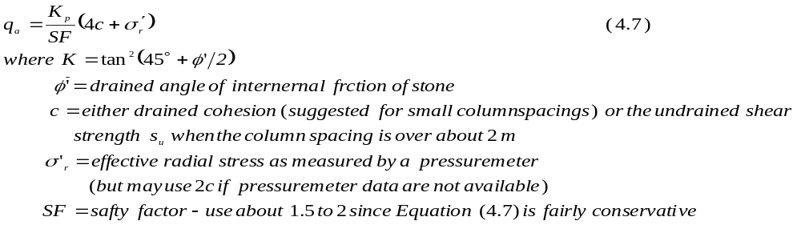
The allowable load P_{a} on the stone column of average cross-sectional area A_{c}=0.7854D²_{col} is
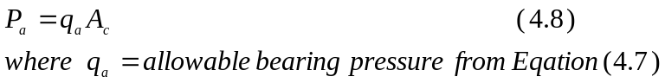

We can write the general case of the allowable column load P_{a} as
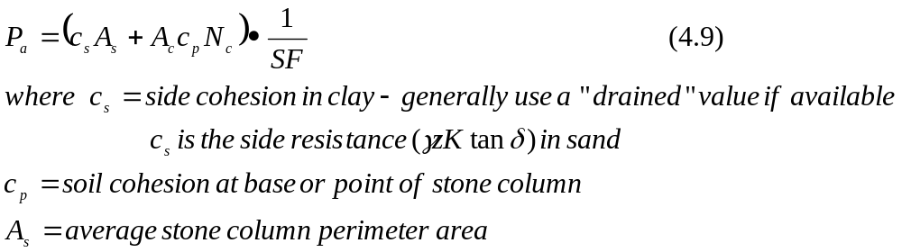

To compute A_{s}, use the in-place volume of stone V_{c} and initial column depth L_{c} as follows;

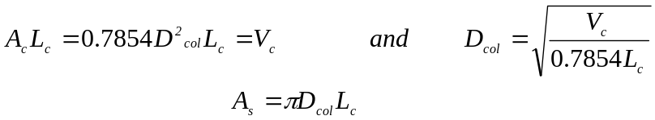

It is to be noted that, while computing the volume of stone V_{c}, the diameter D_{col} is the nominal value. In Equation (4.9), N_{c} = bearing capacity factor described in Chapter 1.

The allowable total foundation load is the sum of the several stone column contributions beneath the foundation area. Stone columns should extend through soft clay to a firm strata to control the settlements. If the end bearing term (A_{c}c_{p}N_{c}) of Equation (4.9) is included, when the column base is on firm strata, a lateral bulging failure along the shaft may result. The bulge failure can develop from using a column load that is too large unless the confinement pressure from the surrounding soil is adequate.

The failure is avoid by load testing a stone column to failure to obtain a P_{ult} from which the design load is obtain as P_{ult}/SF or by using a large SF in Equation (4.9) or by not including the end-bearing term (now one can use a smaller SF).

Taking this factor into consideration gives a limiting column length L_{c} ( in clay based on ultimate resistance) of
P_{ult} ≤ πD_{col}L_{c}c_{s}+9c_{p}A_{c} A_{c}=0.7854D²_{col}
Solving for L_{c}, we obtain
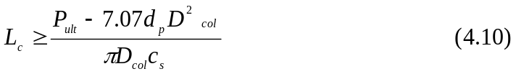
where all terms have been previously identified.

Settlement is generally the principal concern with stone columns since their bearing capacity is usually quite adequate. No method is currently available to compute settlement on a theoretical basis. Settlements are estimated on the basis of empirical methods, of which Fig.4.22 (Greenwood & Thomson, 1984) is typical. From this figure we see that stone columns can reduce the settlement to nearly zero depending on column area, spacing, and initial soil strength.

4.4.5. Application
Applications of the ground improvement by Stone column mainly involves strengthening the bearing capacity of soft ground. Secondary effects include prevention of ground liquefaction, prevention of slope failure and minimizing ground settlement.
A typical application from India is described below.

This particular application involves the improvement of foundation ground of an ammonia power plant, 150 km south east of New Delhi, India (Basakar et al., 2009). The purposes of this project were: 1) to improve the bearing capacity to take up the desired structural loads within the serviceability limits, and 2) to mitigate the risk of liquefaction of the ground.

The bore hole data of the ground indicated that the top 2.5 m stratum of the foundations soil consisted of Clayey Silt (ML-CL) with SPT values in the range of 5 to 6. Underlying stratum mainly comprised of fine sand (SM) having increasing relative density values with increasing depth. SPT values were seen to increase from 6-13 at a depth range 4 to 10 m to about 33 – 84 at 20 m depth. Ground Water Table was reported at 2.8 m below ground.

It was decided to install 7 to 8 m deep stone columns spaced at 1.8 to 2.5m c/c at a triangular grid. (Vivroflot: 400mm in diameter, Wet top feed method, Selected stone: 75 mm down size range). Average diameter of the stone column was in the range of 800 to 850 mm. Overall work on ground strengthening was carried out to ensure that the sandy stratum attained a relative density of 70 to 85%.

The results of the improvement in terms of the SPT values for one particular location is shown in Fig. 4.22 (Basarkar et al, 2009). A significant improvement in the SPT values are evident from this figure.

References
Aboshi H., Ichimoto E., Enoki M. and Harada K. (1979): The Composer-A Method to Improve Characteristics of Soft Clay by Inclusion of Large Sand Columns, Proceeding of International Conference on Soil Reinforcement: Reinforced Earth and Other Techniques, Paris, Vol.1, pp.211-216.
Barksdale, R.D. and Bachus, R.C. (1983): Failure mechanisms of single Stone column in a homogeneous soft layer, EHWA, RD-83/26.
Basakar S.S., Panse V. and Wankhade R.R. (2009): Ground Strengthening by Vibro-stone Column – A Case Study, IGC2009, Guntur, India, Contributory Papers, Vol.1, pp446-450.
Bowles (1977): Foundation analysis and Design (2nd Revised), McGraw-Hill Inc. USA.
Civil Digital (2017): Civil Digital. Com.- The Civil Engineering Website,
https://civildigital.com/wp-conternent/uploads/2017/11/.
Fudo Construction Co. Ltd. (1971): Design Manual of Composer System, (in Japanese)
Greenwood and Tomson (1984): Ground Stabilization: deep compaction and grouting, London, Telford.
Hughes, J.M.O. and Withers, N.J. (1975): Reinforcing of Soft Cohesive Soils with Stone Columns, Ground Engineering, 7-3, pp42-49.
Japan Cement Association (2012): Manual of ground improvement with cementitious solidifying materials, (Version 4), (In Japanese).
Japan Lime Association (2016): Manual of Ground Improvement with Lime (Revised Edition), (In Japanese).
Takahashi, H. (2009): Fundamental Study on the Failure Process of Ground Composed
of Sand Piles and Cohesive Soils, Technical note of the Port and Airport Research
Institute, No.1181, (in Japanese).
Som, M.N, and Das, S.S. (2004): Theory and Practice Design, Prentice-Hall of India Pvt.Ltd.
Suematu, N. (1991): Sand compaction pile method, Manual of soil improvement, pp.325-342, Committee of soil improvement, Material Science Society of Japan, (in Japanese)
Yasuda, S. et al. (1996): Effect of soil improvement on ground subsidence due to
liquefaction, Special Issue of Soils and Foundations, pp.99-107, Japanese Geotechnical
2016, at 03:08)
Zetas: http://www.zetas.com.tr/index.ph?id=22400&dil=EN.

Questionnaires – Practicing what you have learned.

4.1 Is the technique of geosynthetic-encased stone columns in soft clay applicable really? And is it possible to make geosynthetic around a stone column technically?

4.2 Is flyash a good choice for stabilizing dispersive soil?

4.3 What are the influences of chlorine on a cement stabilized sand / soil?

